**Coverage report**

**Failing Regression:**

**Passing Regression after the failing regression:**

**TestCases Mapped:**

**Assertions/Checkers for Tx interface:**

**Assertions/Checkers for Rx interface:**

**Functional Coverage for Tx interface:**

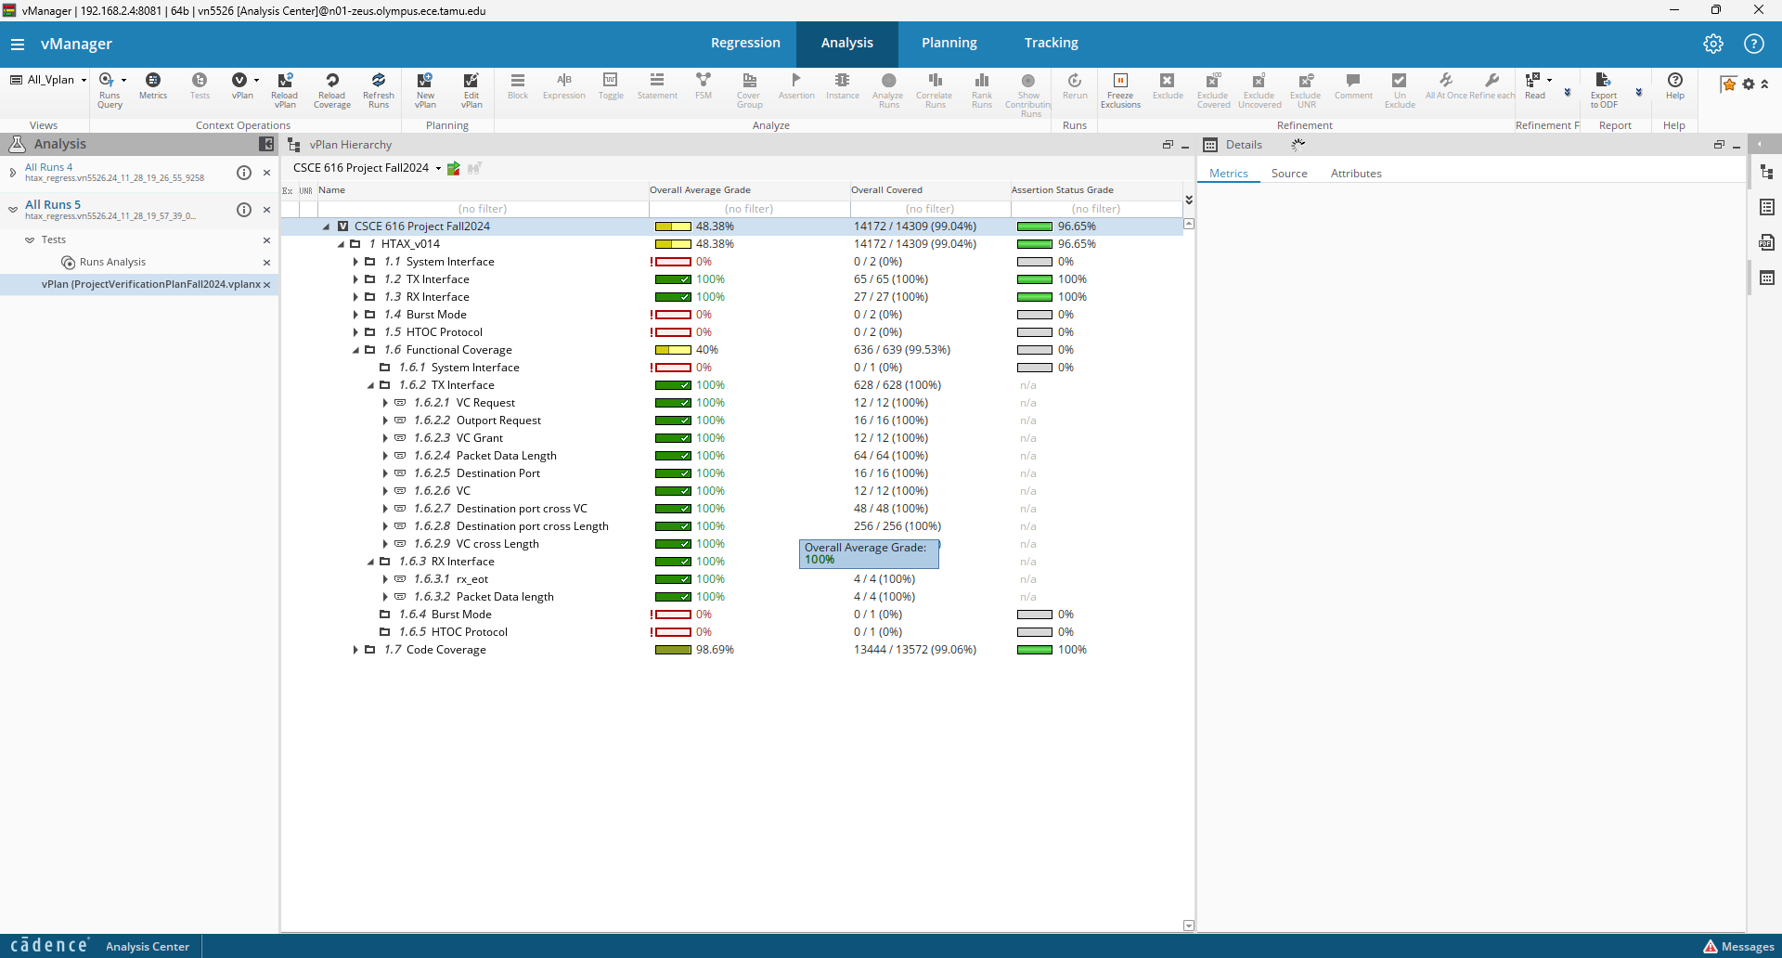

**Functional Coverage for Rx interface:**



**Code Coverage:**

**Code Coverage Holes:**

[Explain any code coverage holes (if any)]

**Bugs report**

**Bug 1**

**What is the bug?**

When multiple short packet sequences are received parallelly on different ports, the rx_eot_timeout_check assertion fails. This means that End of Transmission signal is creating an issue in some part of the design files.

**Where is it?**

Module: module htax_outport_data_mux

File: module htax_outport_data_mux.v

Line number(s): L43

**How to reproduce:**

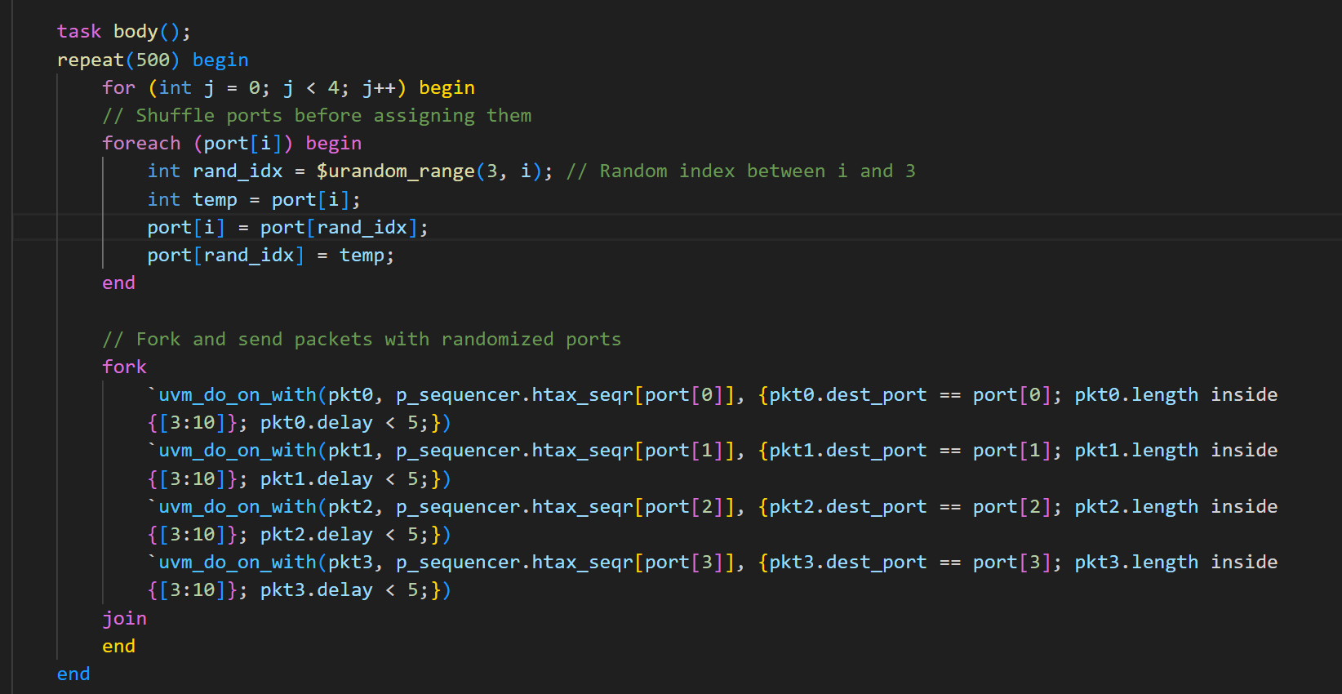

By running this parallelized short-packet test, the assertion bug can be triggered.

**Expected behavior:**

The selected_eot signal in the DUT should correctly indicate the End of Transmission. This should work even if EOT occurs on one or more than one input port. This in turn drives the eot timeout assertion which has a tran_cycles_left counter which should decrement when tran_on is active.

**Actual behavior:**

assign selected_eot = |(eot_in & inport_sel_reg) & ~(&(eot_in));

The selected_eot signal does not assert when all eot_in bits are set. As a result, the tran_cycles_left counter does not decrement and leads to the eot_timeout assertion fails.

**Bug fix:**

Removing the & ~(&(eot_in)) from the design file, should fix the code.

assign selected_eot = |(eot_in & inport_sel_reg);

This way, the selected_eot signal asserts if any valid EOT signal exists. This removes the erroneous dependency on ~(&(eot_in)), which incorrectly deasserted selected_eot when all eot_in bits were set.

**Failing Assertion:**

**Failing Scenario Waveform:**

**Failing Assertion Passing after the fix:**

